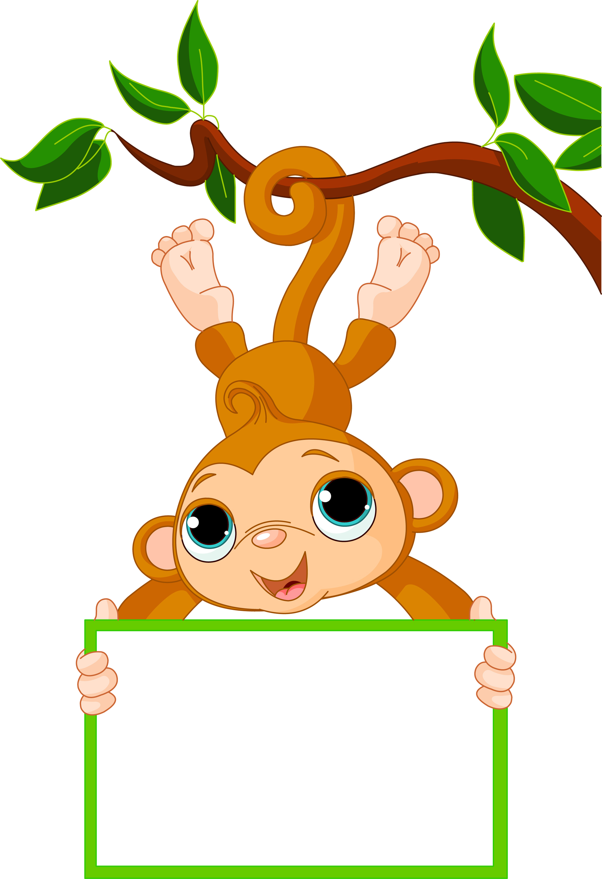

Week of: Sept. 12-16

Letter of the week: B

Numbers of the week: 1 &2

Color of the week: Red

Shape: Circle

We will be working on the Apple theme this week. We will be talking about the parts of an apple, colors, and may even sample a few different apples.

We will be working with the letter Bb this week. Ask your child to find things that start with the Letter Bb. I have several pictures of items that start with the letter Bb on the board in my room, ask your child if she or she remembers any of them.

Activities

AM Preschool Specials

Monday: Music

Wednesday: Mass and Gym

Thursday: Library

Friday: Music

PM Preschool Specials

Monday: Music

Tuesday: Library

Thursday: Gym

Friday: Music

Please remember gym shoes and library books each week.

Reminders

Remember to keep selling those magazines! The students love to have Mrs. Cahoy and Miss Auch feed the emoji’s.

Thanks to all the parents that attended the DQ fundraiser night.

If you have any questions or concerns please ask.

News and Announcements

Mrs. Bechen

Noah’s Ark Preschool