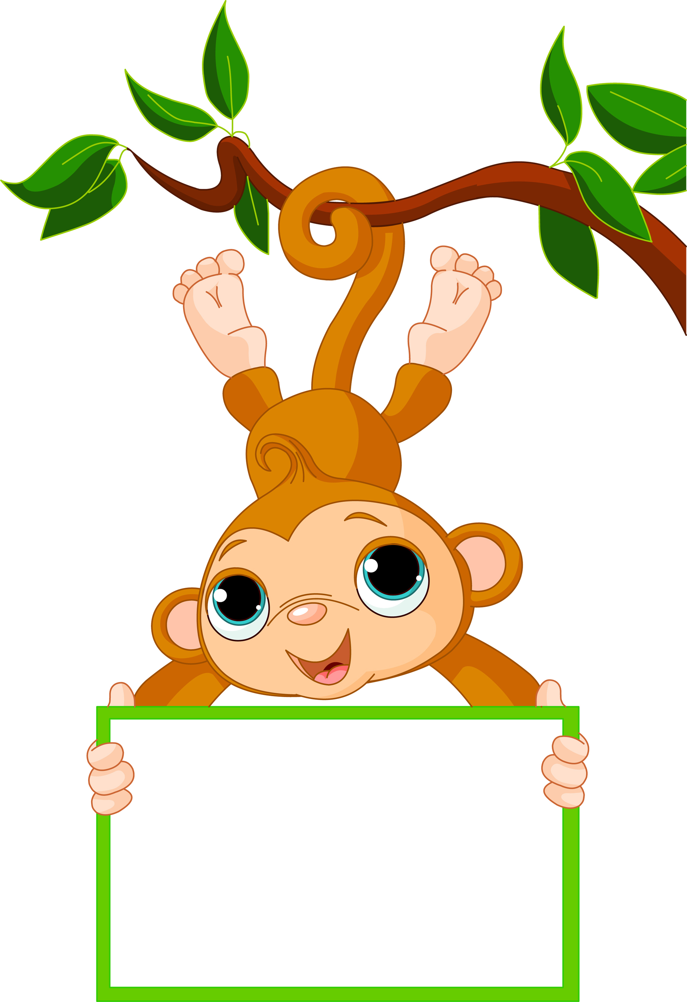

Week of: Sept. 19-23

Letter of the week: C

Numbers of the week: 1 &2

Color of the week: Red

Shape: Circle

We will be working on the Animal theme this week. We will be talking about the different kinds of animals, and we will even make a few animals to hang in the hallway. Come check out our decorated hallway walls.

We will be working with the letter Cc this week. Ask your child to find things that start with the Letter Cc. I have several pictures of items that start with the letter Cc on the board in my room, ask your child if he or she remembers any of them.

We will not be going to mass this week Wednesday.

Activities

AM Preschool Specials

Monday: Music

Wednesday: Mass and Gym

Thursday: Library

Friday: Music

PM Preschool Specials

Monday: Music

Tuesday: Library

Thursday: Gym

Friday: Music

Please remember gym shoes and library books each week. We have several students forgetting to bring library books back.

Reminders

Remember to keep selling those magazines! The students love to have Mrs. Cahoy and Miss Auch feed the emoji’s.

Some parents have asked about the shorts policy. We can pair shorts and capris until the end of September. We will need to have long pants starting on October 1st

I will not be at school on Tuesday. I will be taking my daughter to Sioux Falls to see her neuro surgeon. Please pray for positive news for us.

If you have any questions or concerns please ask.

News and Announcements

Mrs. Bechen

Noah’s Ark Preschool