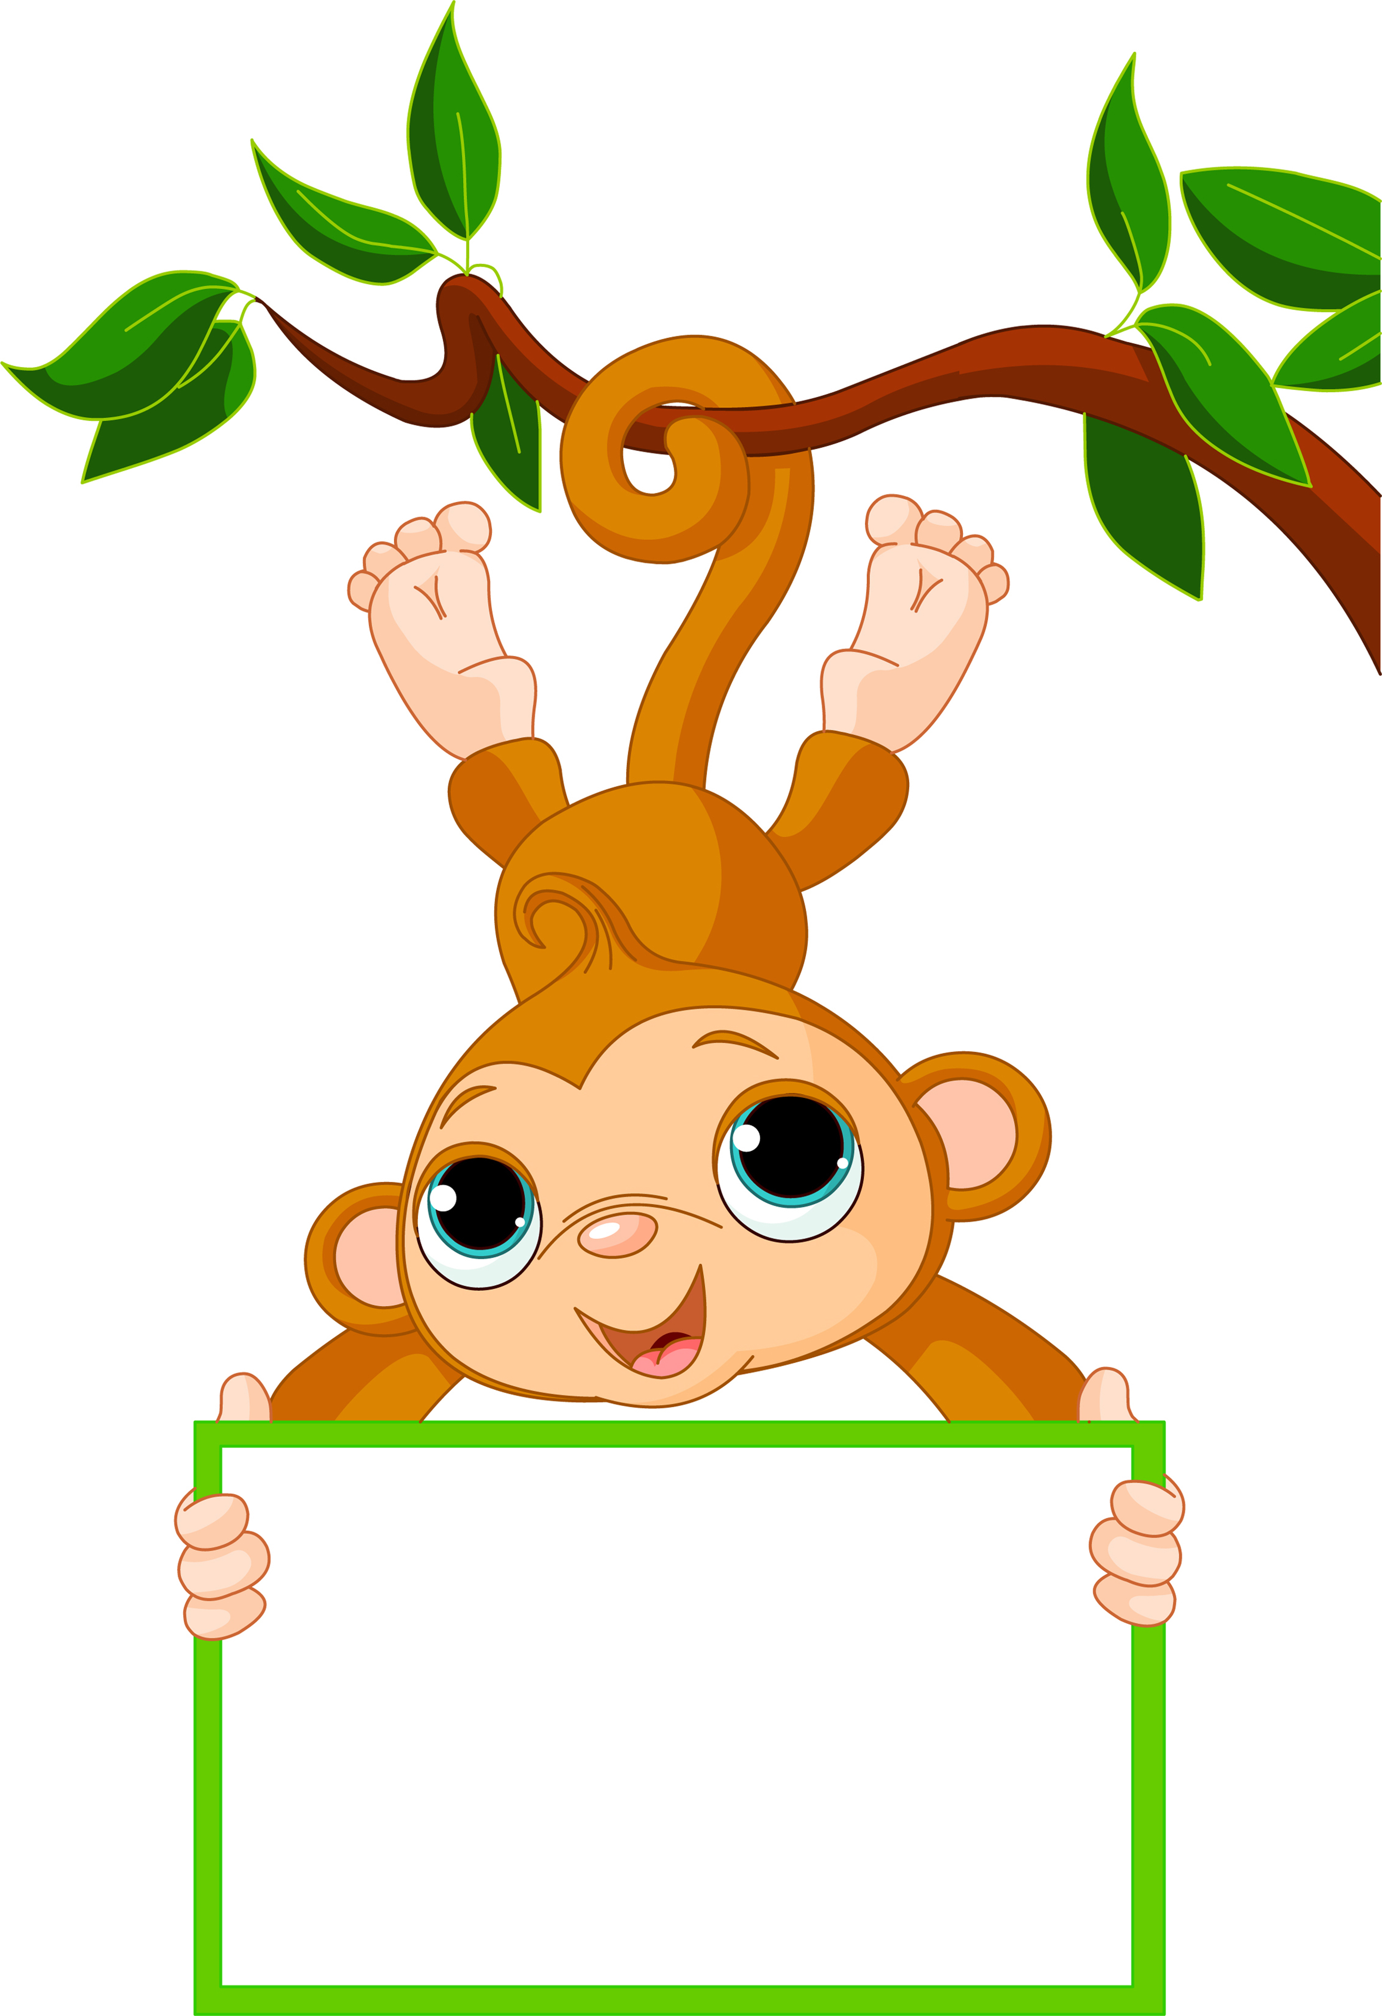

Week of: Sept. 5-9

Letter of the week: A

Numbers of the week: 1 &2

Color of the week: Red

Shape: Circle

We will continue working on our Noah’s Ark theme.

We finished working on The Circle of Grace this week. Please talk to your child about it and have them tell you what a good and bad secret is. We are all trying to keep our little ones safe.

We will continue with the letter Aa this week. Ask your child to find things that start with the Letter Aa. I have several pictures of items that start with the letter Aa on the board in my room, ask your child if she or she remembers any of them.

We will watch the Movie: Two by Two God’s Creatures

Activities

Our snack calendar came home early last week. When your child is down to bring snack please bring enough for the entire class. Please have snack in the original package so we can check the ingredients to make sure they don’t contain peanuts. We do have a couple of students with severe peanut allergies.

If you child wears a dress to school, please have her wear shorts underneath it. We have several girls that like to wear dresses, but when we sit on the floor the dresses seem to come up.

Dairy Queen Night: Tuesday Sept. 6

No school Monday September 5th.

Reminders

We will have an assembly for magazines on Wednesday. We need all students to sell magazines in order to help balance the budget. Please help your child sell magazines to relatives, friends, and neighbors.

We are trying to get into a routine in Preschool. The beginning of a new school year is a little rough at the beginning, but it is fun to watch them grow throughout the year. Change is hard for all of us especially the little ones.

If you have any questions or concerns please ask.

News and Announcements

Mrs. Bechen

Noah’s Ark Preschool